Margaret COLDITZ (née CAMFIELD)
5th August 1926 to 6th April 2020

OBITUARY

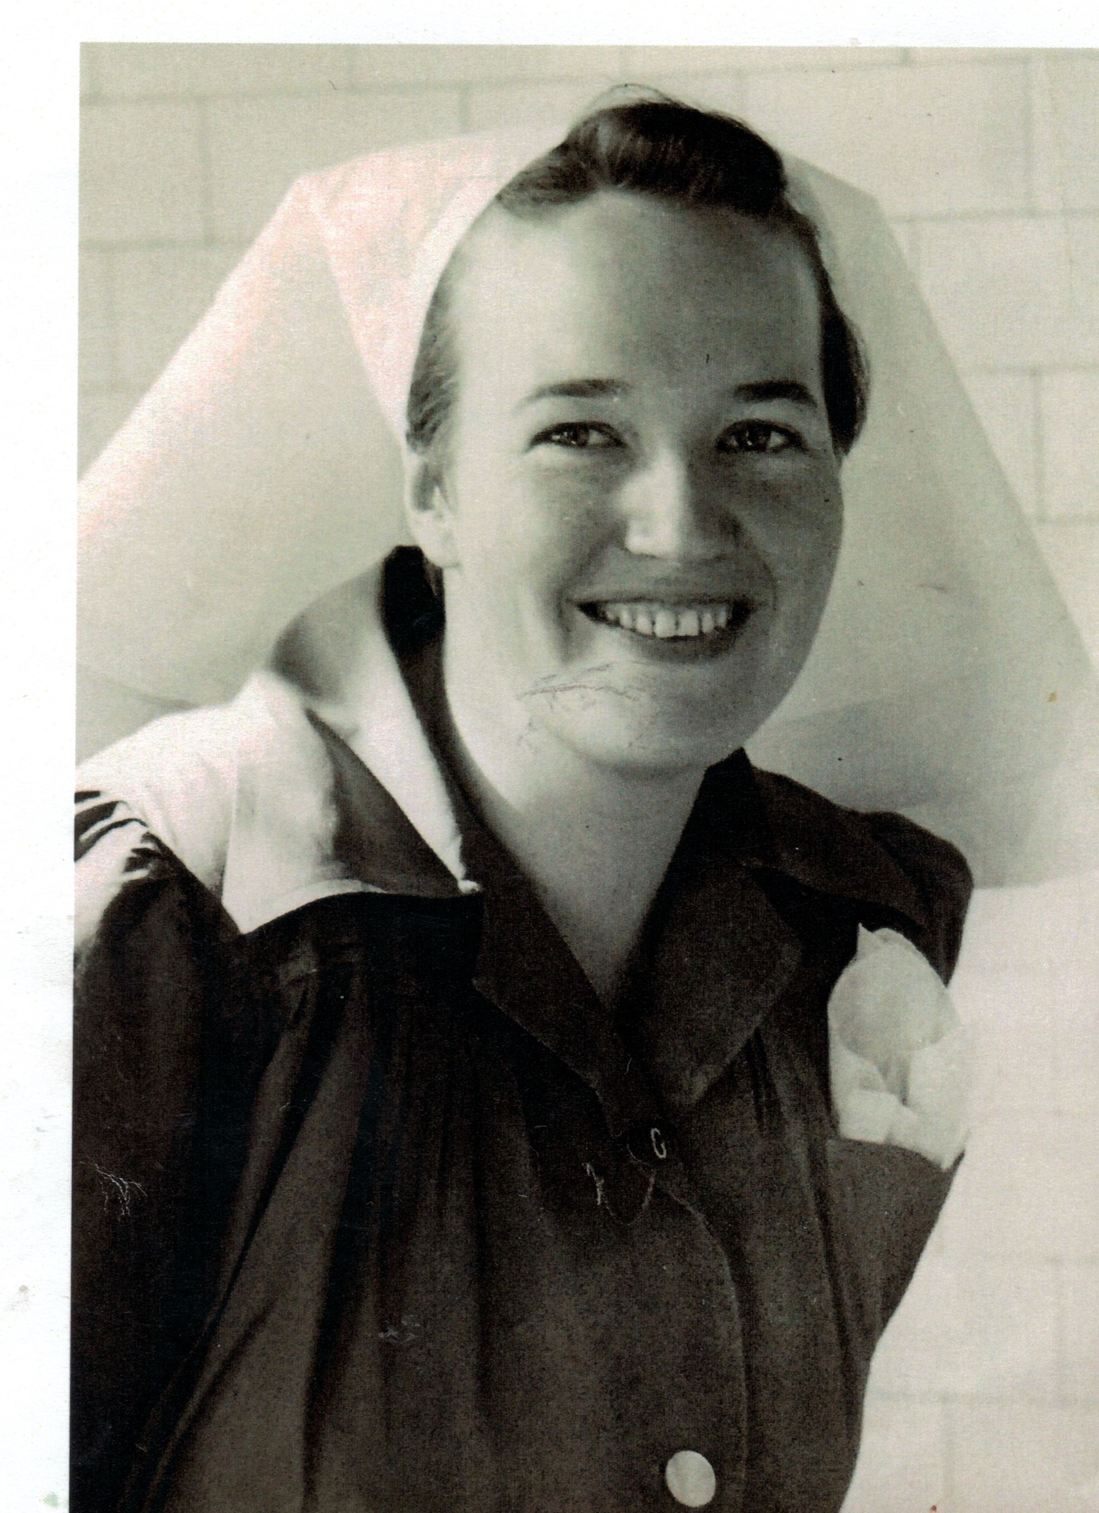

Newcastle Girls’ High School 1939-1943
School Captain 1943.

Trained as a General Nurse, Royal Newcastle Hospital (RNH) 1944-1947.
Midwifery Training in Sydney.
On Staff at RNH 1948- 1950.
Post Graduate Training to become a Tutor Sister, in 1951, at the newly established Australian College of Nursing, Melbourne.
Tutor Sister in charge of the RNH Nurses Training School 1952-1958.

